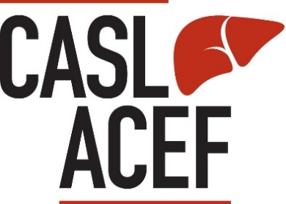
The CASL Executive and Guidelines Committee Guideline invite interested members (and working groups composed of member and non-member representatives) to submit applications for the development of guidelines and related documents in areas of liver-related clinical practice where there would be benefit provided by having CASL-developed or endorsed recommendations.
Application for CASL-Developed and Endorsed Guidelines

Valuable information to consider before you start:
Applications should adhere to the criteria established in the CASL Guidelines Development and Endorsement Policy, and will be accepted twice per year for review by the CASL Guidelines Committee:

- The Spring application period will close April 30th
- The Fall application period will close October 31st
Submit your completed application and supporting documents by email to casl@hepatology.ca with the subject line “Application for Guidelines.”

The CASL office will confirm receipt of your application and advise regarding any requirements that were not addressed within a week of the submission.

Before you submit your application – does your submission package include the following?
- This submission form
- Summary of proposed guideline(s) to be developed, including:
  - Manuscript type
  - Rationale for the topic
  - Name(s) and profession/area of practice for writing group chair or co-chairs
  - Names and profession/area of practice for proposed guidelines writing group members
  - Rationale for inclusion of working group members
- Completed Conflict of Interest (COI) forms for all Guidelines Writing Group members

Guidelines Document Information
Date of submission:
(dd/mm/yyyy)
Name/Topic of the Guideline:
Type of document (select one): | ☐Clinical Practice Guideline  ☐ Position Paper or Guidance Document  ☐Canadian Context and Impact Statement on International Guidelines  ☐ Update to Previously Published CASL-endorsed Guideline
Was the guideline previously published: | ☐Yes ☐ No
Date of previous publication, if applicable:
If yes, has new evidence been published on the topic since the last guideline publication? | ☐Yes ☐ No
Guidelines Writing Group
- Chair or Co-Chair Information | First and Last Name:
 | Organization/Institution/Department:
 | Email: | Telephone #:
 | Does the proposed chair/co-chair have any conflicts of interest within the last two years? | ☐Yes ☐ No
 | Conflict of Interest Form attached? | ☐Yes ☐ No
- Co-Chair (if applicable)  If there are more than two co-chairs, please attach additional information on a separate page | First and Last Name:
 | Organization/Institution/Department:
 | Email: | Telephone #:
 | Does the proposed co-chair have any conflicts of interest within the two years? | ☐Yes ☐ No
 | Conflict of Interest Form attached? | ☐Yes ☐ No
- Committee Member Information
If more lines are needed, please provide list of writing group members as a separate attachment.

Name and Organization of Working Group Member | Relevance to the Guidelines Topic / Area of Focus | CASL Member? | Conflict of Interest Form Attached?
 |  | ☐ | ☐
 |  | ☐ | ☐
 |  | ☐ | ☐
 |  | ☐ | ☐
 |  | ☐ | ☐
 |  | ☐ | ☐
 |  | ☐ | ☐
 |  | ☐ | ☐
 |  | ☐ | ☐
 |  | ☐ | ☐
 |  | ☐ | ☐

Guideline Information
What is the Rationale for the Topic?

